# Assignment - 5

1. Create the following array:

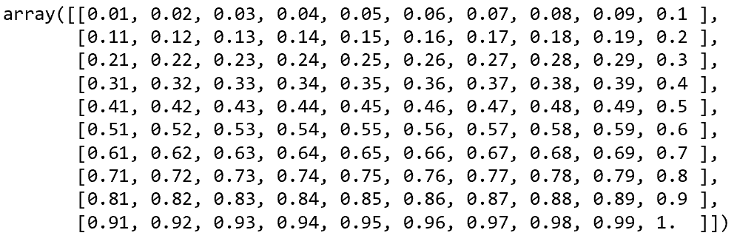

1. Write a code to get the following outputs from the above array

a)

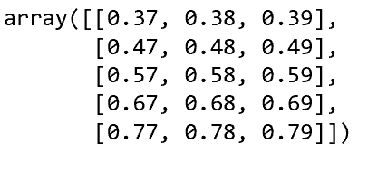

b)



c)

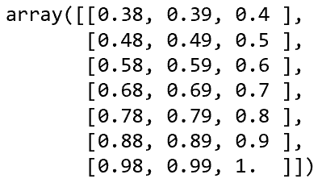

d)

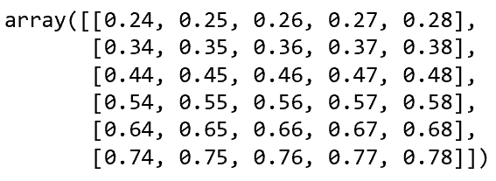

1. Create a 10 X 5 array with values from 1 to 50